Payeer for CMS Prestashop 1.7

Go to admin panel and navigate to «Modules and Services -> Modules and Services».
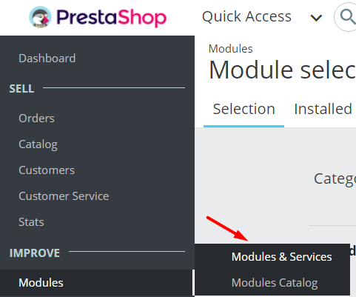

Click «Upload a module».
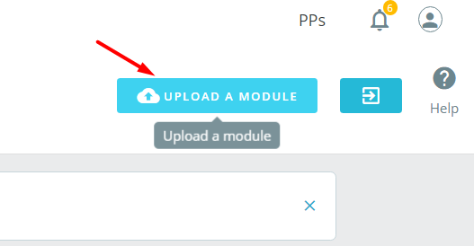

Upload the file payeer.zip and after installation, click “Configure”.
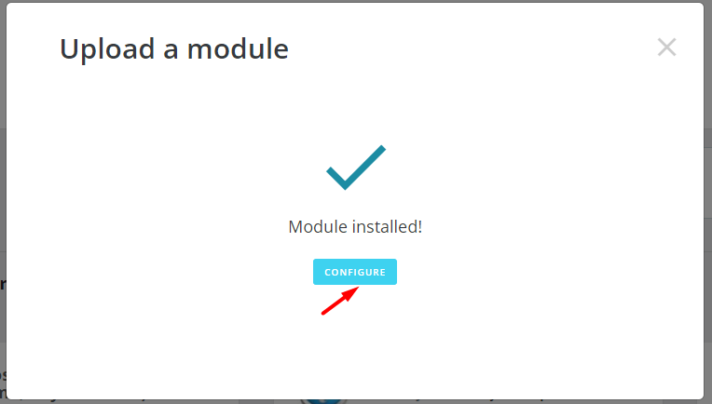
Enter the system settings in the settings Payeer.
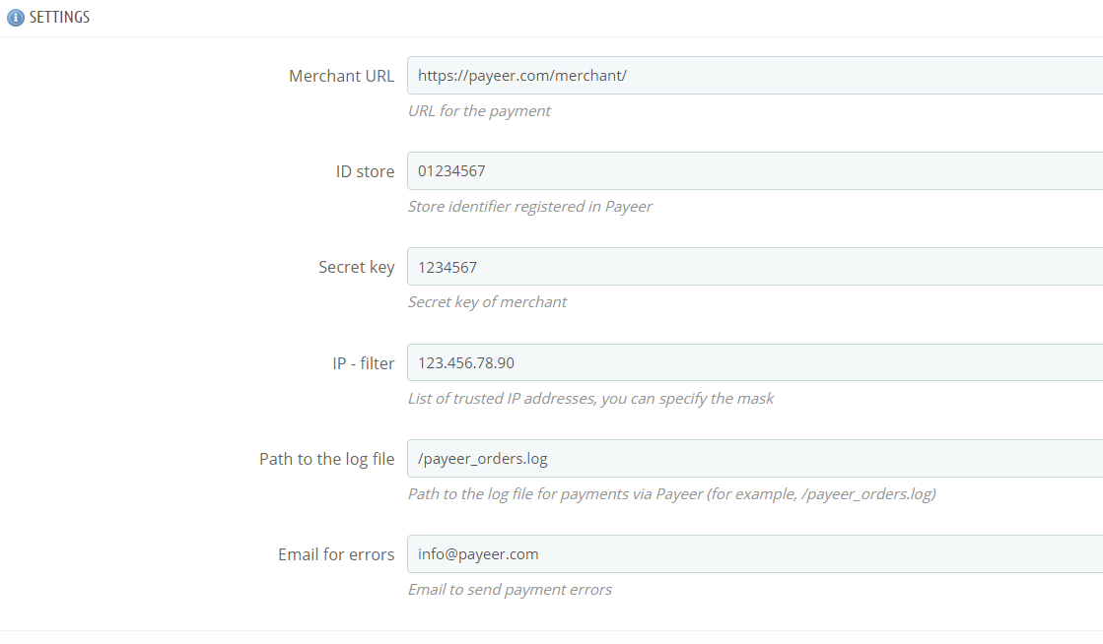

Be sure to fill in:
URL merchant — by default, the path to payment https://payeer.com/merchant/
Merchant ID — id of your store in the system Payeer.com (you can find in personal account)
Secret key – the secret key of your shop
IP–filter — You can specify the list of all trusted ip addresses of servers, separated by commas. You can also specify a mask instead of the ip address. If the field is empty, checking for trusted ip addresses not performed.
For example:
192.168.71.87, 192.165.83.17, 192.178.34.15
Or 192.*.71.87, 192.165.83.*, 192.*.34.15
Or *.*.*.* - all available ip addresses

Email for errors – Enter an email address to which to send notifications in the case of payment errors. The letter will state the reason for and basic information about the payment.
If you specify the path to the file log, it will be recording information about payments through Payeer.
To save the settings, click "Save".

Specify the URL in the “Dashboard Payeer → Merchant → Settings”. URL can be copied from the section “Merchant configuration information” in module settings.

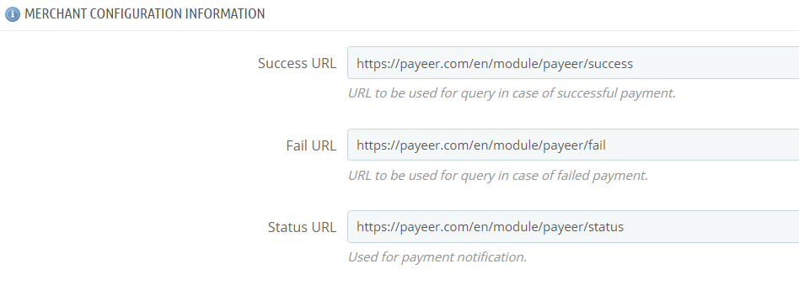
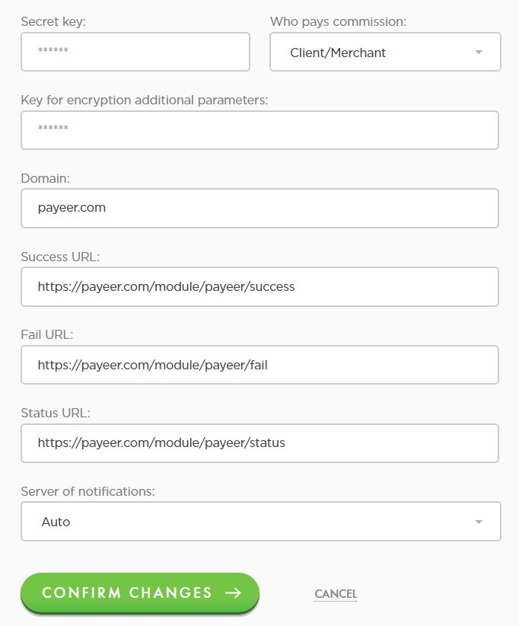

Success URL
http:// *****/module/payeer/success
Fail URL
http:// *****/module/payeer/fail
Status URL
http:// *****/module/payeer/status
Where ***** is your domain

Click “Confirm changes”.
Payeer module for CMS Prestashop 1.7 is configured.

